**What is magnetic field?**

**Ghanshyam Jadhav**

**Dept. of Physics, Shri Chhatrapati Shivaji College, Omerga-413606, India**

**Email: Email: ghjadhav@uniphysics.org.in**

**Web:** [**www.uniphysics.org**](http://www.uniphysics.org)

**Conclusions from the photoelectric effect:**

1. In EM waves, the magnetic force should increase with increase in frequency which should be responsible to produce the photoelectric effect.

2. There should be a phase difference of 90 degree between electric field wave and magnetic field wave in EM waves.

3. Both things are not supported by classical electrodynamics.

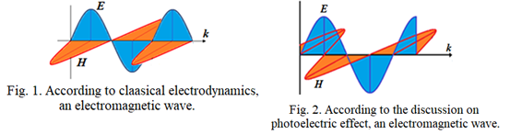

**Fields and their sources:**

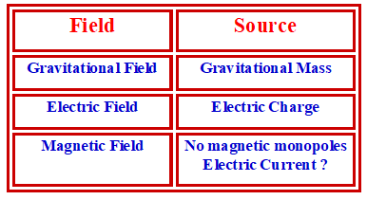

Magnetic monopoles are not found in the universe. They cannot be created in laboratories.

In absence of magnetic monopoles, magnetic field is created, why?

Some interactions created due to electric charges are to be explained in terms of magnetic fields and magnetic forces instead of electric fields and electric forces. That is why we expect something is there that yet to understand.

Our attempt is to trace what could be that.

**Complications in Magnetic field and Magnetic force:**

What do we expect from a field?

Field should be just like a pressure in the surrounding region of the substance. For electric current, it should be either in the direction of the current or opposite.

Force applied by the field on any competent particle should be either in the direction of the field or in opposite.

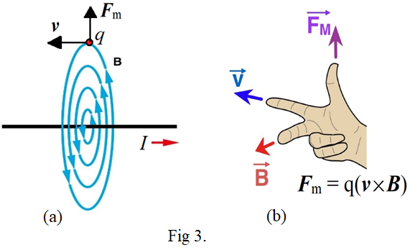

But according to the classical electrodynamics the field produced by a straight current is circular as shown in fig. 3(a). Further the force is not in the direction of the field or opposite. It is perpendicular to both the direction of the field and velocity of the particle.

So things are complex.

**Reinvestigating the field of a current carrying conductor:**

It would be a simple approach to investigate what type of field is being produced by a straight long conductor carrying steady electric current [1]. For that we use a cathode ray tube.

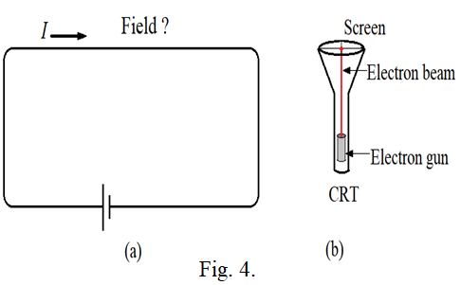

***Assumptions:***

Conductor contains electric charges and no magnetic cahrges. Electric field around the conductor is null before carrying the electric current. Flow of steady electric current throught the concutor causes to move only negative electric charges in one direction. Therefore, the electric field around the conductor cannot be null now. Electric field is simply a pressure around the conductor and can be experienced by placing electric charges in it. This field should apply force on the charged particle in one direction only. Aim is to find the structure of the field.

Deflections of electron beam near straight long conductor carrying steady electric current are shown in fig. 5. At first glance it seems that the electron beam in different directions is experincing forces in different directions which is unexpected. Force should be always in one direction. Therefore, we have to anylayse one by one.

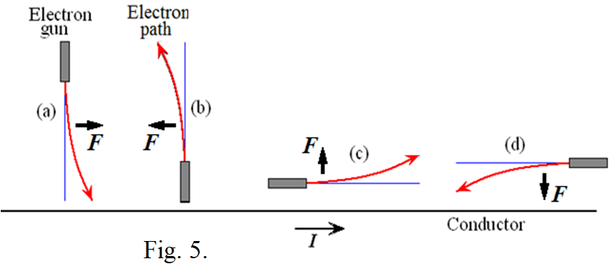

Clearly, when we consider the case (a), the force ***F*** should decrease when we go away from the current as shown in fig. 6. Further, if it is produced by electric field ***E*** then the field should be in opposite direction of the force as shown in fig. 6. The force experienced by the electron should be asymmetric in nature and should be existed in terms of field-field interactions as explained below.

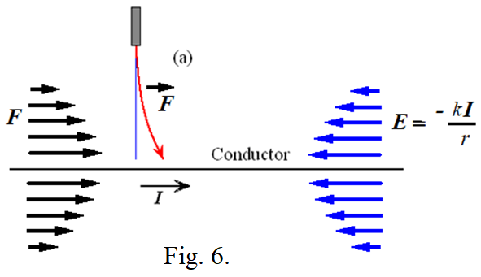

**Force through field-field interaction:**

Let us see generalization of the electric force with time in classical electrodynamics.

**Case (1):** In fig. 7(a), the force between the two charges is expressed in terms of their charges. It may be considered as force in terms of charge-charge interaction.

**Case (2):** In fig 7(b), charge q1 produces electric field ***E***1 around itself. If another charge q2 is brought into the field then the field applies force on the charge. It may be considered as force in terms of field-charge interaction. The force equation is given by ***F***2 = q2*­­* ***E***1, where ***E***1 is the electric field produced by charge q1 at position of charge q2. Force is mutual. Therefore, charge q2 also applies force on charge q1 in terms of field-charge interaction by ***F***1 = q1*­­* ***E***2, where ***E***2 is the electric field produced by the charge q2 at position of charge q1.

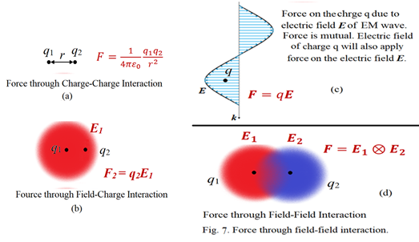

**Case (3):** In fig. 7(c), an electric field wave in an electromagnetic wave is propagating with speed of light and interacts with a charge q at an instant. This field also applies force on the charge in terms of field-charge interaction. If ***E*** is the electric field of the electric wave at position of the charge q at an instant then the force equation is ***F*** = q***E***. But the force is mutual. Hence the charge q should also apply force on the electric field of the wave. As there is no charge associated with electric field of the wave, the electric field of the charge q must apply force on the electric field of the wave which may be considered as force through field-field interactions. Obviously, as the subjected charge q is always associated with its own electric field, therefore, the electric field of the applied wave must apply force on the field of the charge resulting into the force through field-field interactions. Thus finally one can conclude that the electric force exists not in terms of charge-charge interaction or field-charge interaction but it exists in terms of field-field interactions.

**Case (4):** In fig. 7(d), if two charges are brought close to each other, then force between them, either attractive or repulsive, is existed in terms of their field-field interactions. It means the electric field of first charge exerts force on the electric field of the second charge and vice versa. Thus a new electric force equation is to be developed which could explain the force in terms of the field-field interaction. Thus, we consider existence of electric force in terms of the field-field interactions for further discussion.

Using the concept of force through field-field interactions, let us once again explain the deflections in fig. 5 with reconsidering in fig. 8.

In case (a) of fig 8, the front field of the electron in the electron beam experiences greater force than the back field because of which it gets pushed along the direction of the force. In case (b), the back field of the electron experiences greater force than the front field because of which it gets pushed in the opposite direction of the force. In case (c), the lower field of the electron in the electron beam experiences greater force than the upper field while acceleration because of which it gets pushed into the weak field region. In case (d), the lower field of the electron experiences greater force than the upper field while deceleration because of which it gets pushed into the strong field region.

Things seem to be very different from our belief. But according to the discussion of photoelectric effect, if we found increase in frequency of EM wave causes to increase in magnetic force and a phase difference of 90 degree in electric field wave and magnetic field wave in EM wave, then we are compelled to reinvestigate the real nature of magnetic field. At present, we have no any other option than to accept the above possibilities.

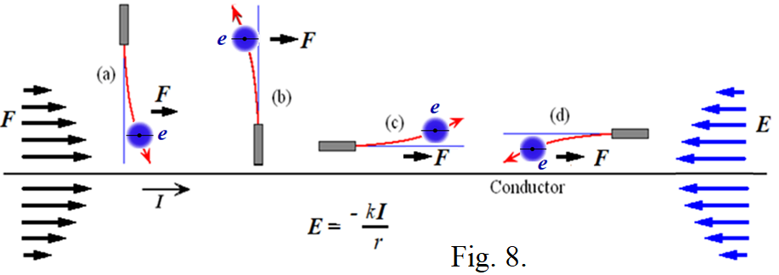

**Electric field of coil and bar magnet:**

Electric field is parallel to the current and in opposite direction. Therefore a circular current carrying coil should a circular electric field.

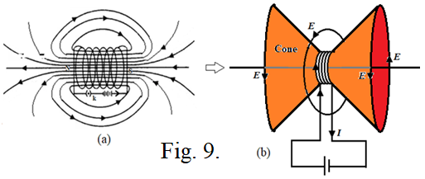

Electric field near the conductor of the coil is maximum. Therefore, cones of electric field are formed at both ends of the coil. Surface of the cone is formed where the magnetic field lines get turned. Electric field is maximum at the surface of the cone. Electric field decreases away from the coil.

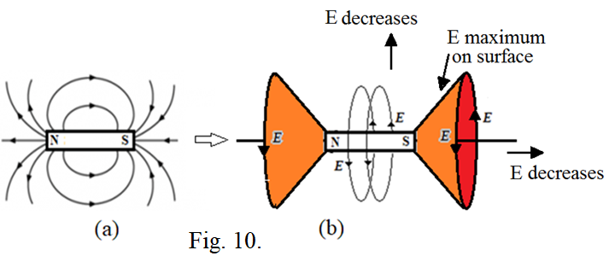

In bar magnet, spin of unpaired electrons is aligned in such a way to produce non-zero effective current by them. This current is responsible to produce a circular electric field around the bar magnet as shown in fig. 10(b). Obviously, this electric field is in opposite direction of the effective non-zero current. Two cones of electric field are formed at both said poles of the magnet. Electric field is maximum on surface of the cones and decreases away from the bar magnet in all directions.

Current produced in a superconductor supports to the circular electric fields produced by a current carrying coil and a bar magnet.

The electric field of the coil tries to accelerate the charged particles in the direction of the field producing circular current in the superconductor because of which the superconductor gets pushed away from the coil in the weak field. Because of that we consider superconductor as a diamagnetic material.

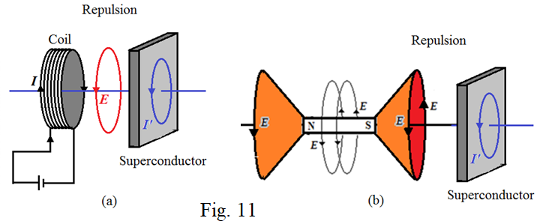

Similarly the electric field produced by the current in the superconductor pushes the coil apart resulting into the repulsion between them because of which the superconductor is considered as diamagnetic material. Similar thing happen with bar magnet.

*Such current is not produced in ordinary conductors and is a part of investigation. If the applied electric field is alternating then produces alternating current in ordinary conductor and is governed by Faraday’s law of electromagnetic induction. Though we know magnetic field and magnetic force, why we require the Faraday's law to tell emf produced in secondary circuit is really beyond our imagination.*

**Verification of the electric field cones produce by circular current:**

As the electric field is maximum close to the current, therefore, electric field strength should be maximum near the wires forming circular cones at both ends of the coil. The electric field in the region of the cone should increase away from the axis of the coil towards the surface of the cone while going in perpendicular to the axis. It should be maximum on the surface of the cone. Similar type electric field should also be produced by a bar magnet. The direction of the electric field is same everywhere in the surrounding region of the coil and bar magnet and is circular about axis of the coil.

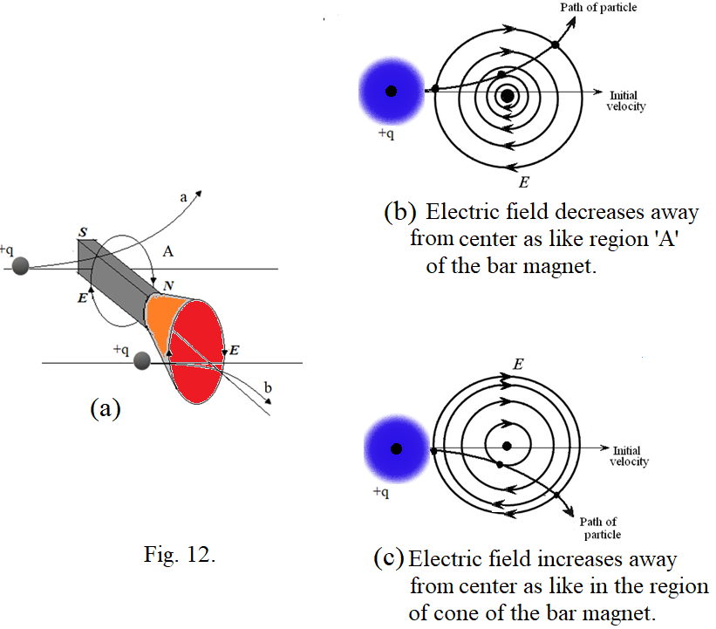

The deflections of a charged particle in the electric field of bar magnet are shown in fig. 12. In region ‘A’ of the bar magnet it goes in upward direction while in the region of cones it goes in downward direction thought the field direction is same at both regions. This is because in which direction the field is increasing or decreasing means the field strength is increasing or decreasing while going away from its center will decide in which direction the particle is to be deflected. In region ‘A’ of the magnet, the electric field decreases away from center of the bar magnet which is illustrated in fig. 12(b). The charged particle deflections can be understood using the four deflections shown in fig. 8. If the particle is coming into the strong field region then it gets deflected in the direction of the force. If the particle is going into the weak field region then it gets pushed in opposite direction of the force. If the particle gets accelerated then it gets pushed into the weak field region and if it gets decelerated then it gets pushed into the strong field region. Using these facts, the deflections in the surrounding region of the bar magnet can be understood which supports to the formation of the electric field cones.

Possible electric field cones at both poles of earth are shown in fug. 13. Formation of aurora in ring shape at both poles of the planets (fig. 14) supports to the formation of electric field in the form cones at both poles of the planets.

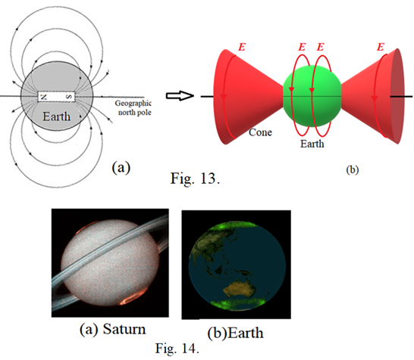

**Attraction between poles of magnets:**

Attraction and repulsion between magnetic poles is an important phenomenon in magnetism.

In fig 15(a), the electric force and spin direction of the electron are opposite to each other. Therefore, the electron gets dragged towards the magnet into strong electric field.

In fig. 15(b), the electric field of magnet M1 applies force on the unpaired electrons in magnet M2 in opposite direction of their spin because of which these electrons and hence the magnet M2 gets dragged towards magnet M1. In similar way the electric field of magnet M2 reacts with the unpaired electrons in magnet M1. Thus there is no direct attraction between the magnets.

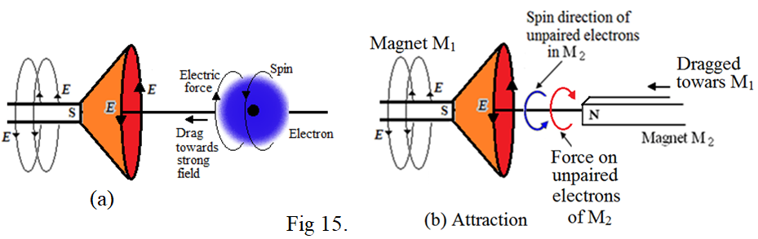

**Repulsion between poles of magnets:**

In fig 16(a), the electric force and spin direction of the electron are in same direction. Therefore, the electron gets pushed away from the magnet into weak electric field.

In fig. 16(b), the electric field of magnet M1 applies force on the unpaired electrons in magnet M2 in same direction of their spin because of which these electrons and hence the magnet M2 gets pushed away from magnet M1. In similar way the electric field of magnet M2 reacts with the unpaired electrons in magnet M1. Thus there is no direct repulsion between the magnets.

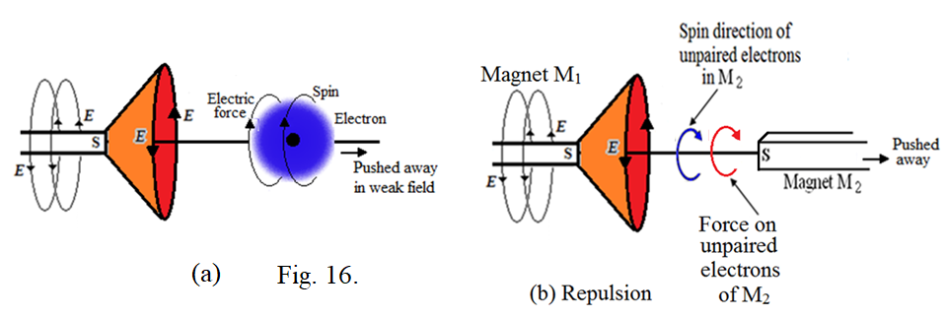

**Magnetization produced in paramagnetic or ferromagnetic materials:**

Magnetization produce in magnetic materials is an important phenomenon in magnetism.

Suppose a paramagnetic or ferromagnetic material is brought near a bar magnet. If an unpaired electron in the material possesses spin in opposite direction of the force applied by the electric field of the magnet then there will be attraction between the electron and the magnet resulting no change in the spin direction. There will be no change in the spin direction of all such electrons.

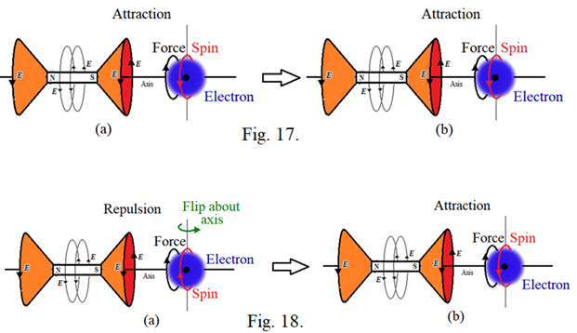

If an unpaired electron in the material possesses spin in same direction of the force applied by the electric field of the external magnet then there will be repulsion between the electron and the magnet resulting flip of the spin of the electron about the vertical axis as shown in fig. 20. It tends to align the spin of the electron in opposite direction of the force producing attraction between them and no flip of the spin further. It happens for all such electrons. In this way the spin of all unpaired electrons get aligned in opposite direction of the force produced by electric field of external magnet. Such alignment of the spin of unpaired electrons in the paramagnetic or ferromagnetic material is nothing but the magnetization. Due to the spin alignment of the unpaired electrons in the material, its net electric field becomes nonzero and it will be circular and will be in the same direction of the spin motion of these electrons or in the same direction of the electric field of the external magnet.

**Conclusion:**

According to the discussions in the photoelectric effect, the magnetic force should increase with increase in frequency of electromagnetic wave. Further, there should be a phase difference of 90 degrees between the electric field wave and magnetic field wave in an EM wave. Both things are not supported by the classical electrodynamics. Further it is found that the apparent force produced due to the existence of asymmetric electric force works similar to the magnetic force implying that the apparent force can be the true face of magnetic force giving answer to the absentee of magnetic monopoles in the universe. On advent of these findings, a straight current should produce a parallel electric field and a coil and a bar magnet should produce a circular electric fields with having two electric field cones at the said poles of the magnet. Related things should go as discussed above. Further investigation is essential in this regard.

**References:**

1. G. H. Jadhav, On static curled electric field produced by a steady current of magnetic monopoles, Proceeding of ‘2011 Annual Meeting of Electrostatic Society of America’, pp.1-7 (2011).

**---------------------------------------**